NOMINATION

2023 Molly Krival Refuge Friends Group of the Year Award

Nominee Group: | Friends of Lower Suwannee & Cedar Keys NWRs
Group President: | Ginessa Mahar, PhD
Nominee’s Mailing Address: | P.O. Box 532, Cedar Key, FL 32625
Nominee’s Telephone Number: | 631.839.1140 (Ginessa Mahar)
Nominee’s Email Address: | friends@friendsofrefuges.org
Refuge: | Lower Suwannee & Cedar Keys NWRs
Refuge Mailing Address: | 16450 NW 31 Pl, Chiefland FL 32626
Refuge Telephone Number: | 352.493.0238 - office
Refuge Manager: | Andrew Gude
Refuge Manager’s Email Address: | Andrew_Gude@fws.gov
Nominated By
Name: | Andrew Gude
Title/Relationship to Group: | Refuge Manager
Mailing Address: | 16450 NW 31st Place, Chiefland, Florida 32626
Email Address: | Andrew_Gude@fws.gov
Telephone Number: | 703.622.3896
Date: | March 17, 2023

Accomplishments and attributes of the nominee in the following categories:

Innovation and Excellence in . . .

- Advancing the mission of the National Wildlife Refuge System (NWRS).

The Friends group’s goal is to build the community support and presence that our Refuges need to fulfill their mission of conserving, managing and, where appropriate, restoring the fish, wildlife and plant resources and their habitats on the Lower Suwannee and Cedar Keys National Wildlife Refuges (NWRs) for the benefit of present and future generations.

Our Friends group supports the mission of the NWRS by providing advocacy and physical support for the Lower Suwannee & Cedar Keys NWRs. For example, they organize volunteers to advocate with our cell service providers to expand cell and broadband service on the Refuges, work on control of Brazilin peppers and other invasive species, provide education and outreach programs are multiple community events, provide the Refuge’s Junior Ranger Program, and host an incredible website that is essentially our primary visitor service tool.

2. Providing a supporting influence in the development of a positive relationship between the refuge and the local community.

Communication and Interaction
- Working closely with our Refuge Manager and the Refuge staff, Friends of Lower Suwannee & Cedar Keys NWRs works as a steady and reliable channel of communication and positive interaction with:
  - Local communities
  - Seasonal residents
  - Occasional visitors
  - Specific user groups (including but not limited to anglers, hunters, “butterfliers”, birders, and bikers)

- We provide several means of getting involved and submitting comments and questions about the Refuge and its operations, including at in person outreach events and online via their website and social media platforms. Our region is primarily rural and, so far, largely an undeveloped part of the heavily populated State of Florida. With its abundance of Refuge and other land in conservation, in working forests, farms and ranches, and aquaculture, our hurricane-absorbing region enables a natural resource-based economy and quality of life that are consistent with the mission of the National Wildlife Refuge System and supports the lifestyles and cultural heritage of the people and who live here.

How Friends helps to develop positive relations between the Refuge and local community:

- Maintaining a strong, active membership base. During the pandemic, the membership in our Friends group fell from a high of 260 individuals to a low of 215. As of our Annual Meeting on February 25, 2023, our membership has rebounded to 290. This strong show of support for our Refuges is despite the fact that we are happily a low population area. Of the 67 counties in Florida, the three counties adjacent to our Refuges are the 24th, 9th, and 8th smallest in population in the state.

- Setting up and volunteer staffing Visitor Contact booths in Cedar Key, Town of Suwannee, at three annual festivals that together attract more than 25,000 visitors, as well as on the Shell Mound Unit of the Lower Suwannee NWR, the River Trail, and Seahorse Key Open Houses.

- Designing and implementing Posters with QR Codes with Refuge information and hiking/biking/kayaking trail guides based on our brochures.

- Designing, producing, and distributing information cards to encourage hunters and fishers to support the overall mission of the Refuges.

- Initiating a Junior Ranger program to engage K-12 youths on the Refuge.

- Initiating and maintaining a robust website with current information about Friends and the Refuges. Unique visits and pageview regularly run at about 2,000 and 4,000 per month.

- Preparing and distributing a monthly email newsletter with more than 550 subscribers.

- Conducting nature, butterfly, photo, and native plant walks, in addition to hosting Summer and Winter Solstice celebrations at Shell Mound and working with partners in our communities to provide lectures that engage and educate the large numbers of seasonal and occasional visitors about the Refuges.

- Initiating a demonstration of EcoRover equipment that may in the future be able to provide better access to trails for mobility-limited visitors.

- Working as an independent advocate to protect natural resources.

Planning and fund raising to use the gift of a 14-acre historic property inholding on the Suwannee River to tell the story of the Lower Suwannee NWR, its history and its contributions to the region and nation.

- Friends applied for and received two competitive grants from Florida Division of Historical Resources
  - The first, in 2019, provided $50,000 for an expert assessment of cultural, historical, and structural resources of the Vista property gifted to the Lower Suwannee Refuge by two women descendants of the Cummer Lumber family.

  - The second, in 2022, will provide $75,000 including a $15,000 match which Friends has already raised, to begin repairs on at least one of the historical buildings the property.

- Production of a Guide to the Butterflies of the Lower Suwannee NWR which helps visitors to identify butterflies, establishing a connection between people and insects. Our goal is that this connection will further public advocacy regarding the plight of butterflies and other pollinators. The book was authored by a Friends board member who is an accomplished butterfly expert and photographer.

- Support for the tracking Swallow-tailed Kites that nest on the Lower Suwannee NWR by the Avian Research and Conservation Institute as they migrate between the Lower Suwannee National Wildlife Refuge and their winter home in Brazil. We have supported the tracking of two birds, Suwannee I and Suwannee II, the latter of which is still sending data and is on his return flight now. This initiative has been very helpful in communicating the conservation status of today’s Swallow-tailed Kites.

- Cooperating with other Friends organizations locally, regionally or nationally, and participating where possible in collaborative programs with these groups as well as with the National Wildlife Refuge Association.

- Several members of Friends board of directors met in January 2023 with Friends of St. Mark’s NWR to share information about our nature stores and our grant-funded efforts to help preserve Refuge historical and cultural resources in order to advance understanding of and support for the Refuges’ mission and goals.

- Our president Debbie Meeks participated in the 2022 Friends Academy.

- Friends Immediate Past President and the Assistant Manager of our Refuges will participation in the April 2023 Friends/Fish and Wildlife Service Conference.

- Our Friends group has been an active participant in multiple CORFA/NWRA webinars and Zoom meetings over the past 3 years. More than 10 Friends board members have been engaged in them and new board members have participated in Board Orientation the webinar led by Cathy Allen, the Board Doctor.

- Maintaining a relationship of cooperation and mutual respect with U.S. Fish and Wildlife Service personnel.

- The Refuge Manager and/or Assistant Manager attend all Friends board meetings.

- Friends’ website is the Refuge Manager’s go-to communication venue for community messaging and powerful visitor service information for the Refuges.

- Friends provides graphics and draft narratives for interpretive panels and brochures for Refuge staff as well as the brochures and panels Friends initiates.

- Our Friends group is led by a “presidential trio”, each of whom serves for one year in each role of president-elect, president, and then immediate past president. Friends’ “Presidents”, the Refuge Manager, and the Deputy Manager have open and productive communication channels that result in informal and formal conversations at least weekly, if not multiple times per week. As the Refuge Manager, the presidential trio along with discipline-specific Board Members, essentially serve in volunteer staff positions related to birds, pollinators, hikers/bikers, hunters, and graphic and website producers.

- Adhering to high ethical standards of behavior applicable to private nonprofit charitable organizations and adhering to all reporting requirements and other regulations required by state and federal law.

- Our Friends group developed and maintains a Policies and Procedure Manual, has an annual Financial Review by a committee that includes non-board financial expertise, signs annual conflict-of-interest statements, and assures annual orientation for new board members to our active and engaged, 17-member board.

- To assure transparency with all the members, our board meetings are open. We are current with all registrations and compliance requirements. Friends has a Gold rating with GuideStar.

( continued )

Friends of Lower Suwannee & Cedar Keys NWRs Photos

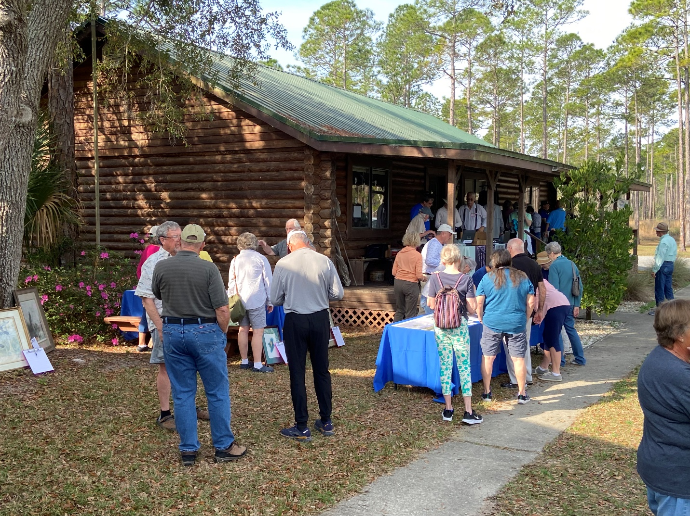
Friends members registering for Annual Meeting 2023

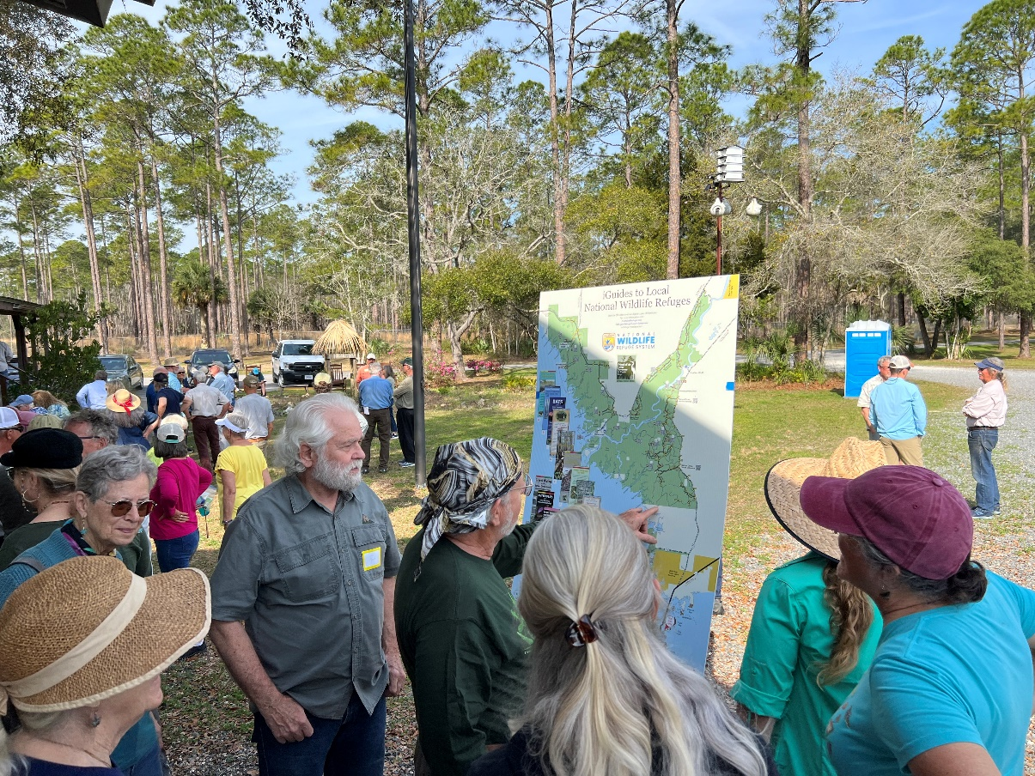
Informal tutoring on using QR codes to download brochures and maps from the new panel

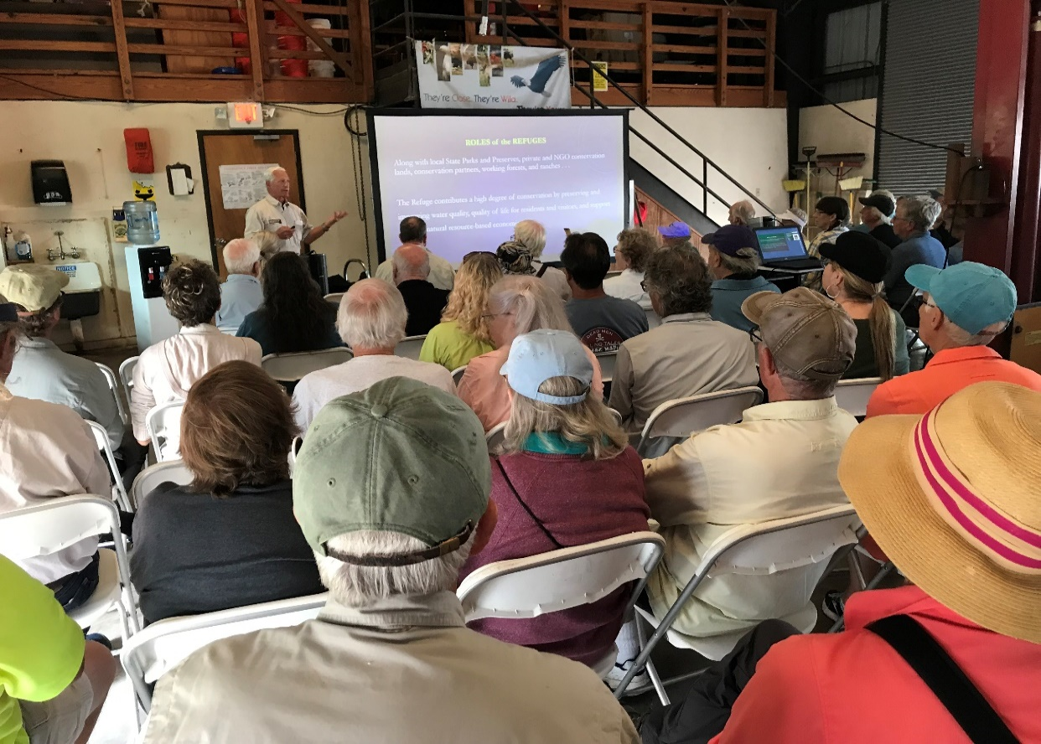
Refuge Manager Andrew Gude giving Refuge update at Annual Meeting 2023
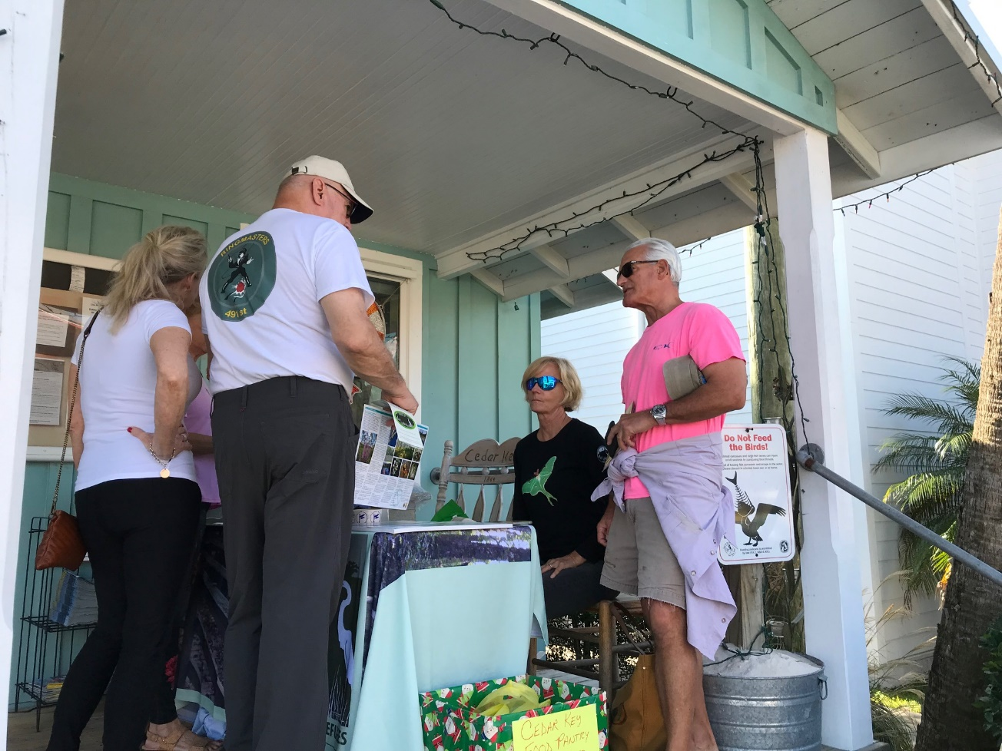
Board members and Refuge Manager greeting visitors at Welcome Desk in Cedar Key

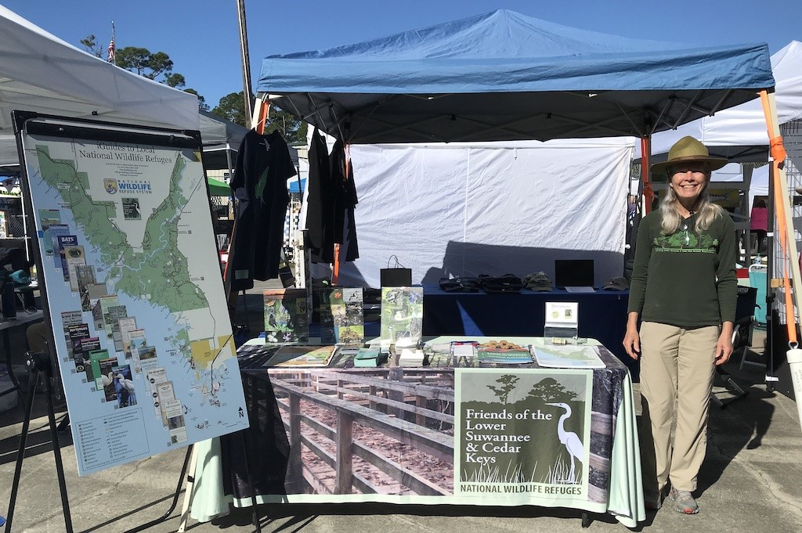
Board president greeting visitors at town of Suwannee Festival Friends booth
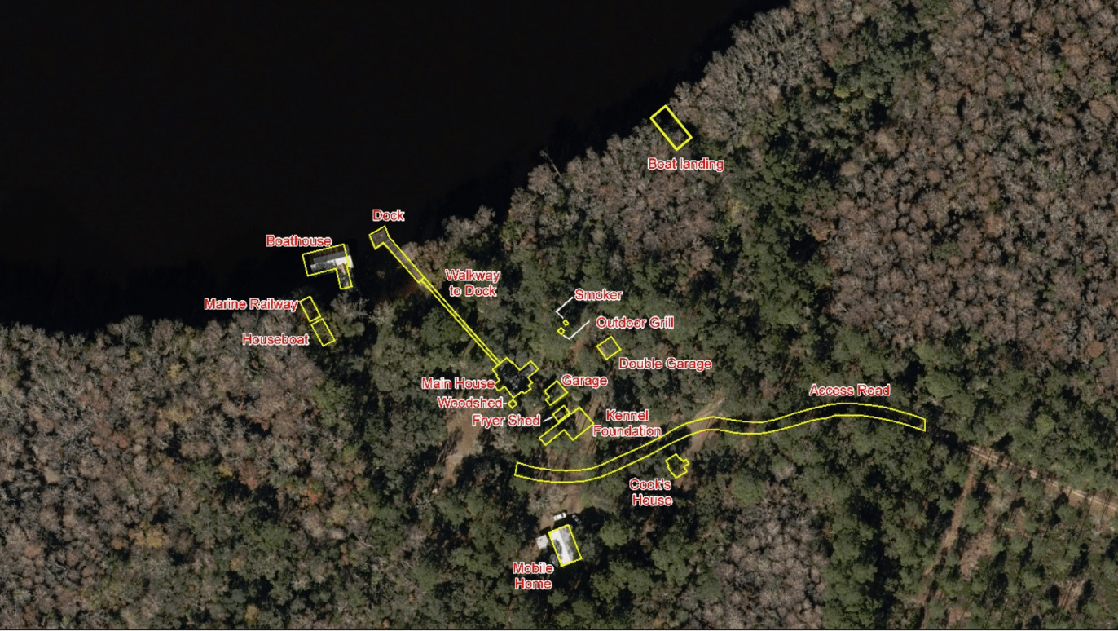
Schematic of the historic Vista property from Friends’ grant-funded Historic Assessment

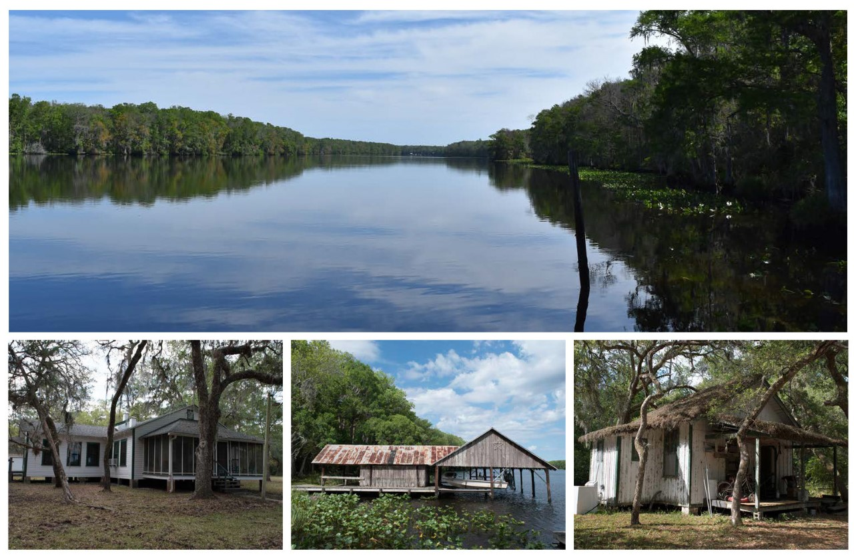
Collage of the Vista property from the Historic Assessment report

